**Small Project Application**

**Guardbridge War Memorial**

We are applying to Aviva for £25,000 in order to construct a new war memorial that is fit, not only for David Finlay VC but for all Guardbridge heroes who were killed in the WW1, WW2 and beyond. This is a very auspicious time to achieve our aim as we now have the Army based at Leuchars (1.5miles away) and we would like to have the new war memorial erected and in place ready for the centenary of the end of WW1 in November 1918.

We are a small group of volunteers who have recently been elected to serve on the community council for the village of Guardbridge near to St Andrews in Fife.

The village is sub-named ‘The Birthplace of David Finlay VC’ and this is placed on the village name sign at each road entry into the village.

**David Finlay VC**

[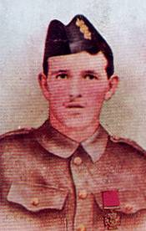](https://en.wikipedia.org/wiki/File:VCDavidFinlay.jpg)On 9 May 1915 near Rue du Bois, France, Lance-Corporal Finlay led a bombing party of 12 men in the attack until 10 of them had fallen. He then ordered the two survivors to crawl back and he himself went to the assistance of a wounded man and carried him over a distance of 100 yards of fire-swept ground into cover, quite regardless of his own safety.

Finlay was later promoted to the rank of sergeant. He was killed in action in what is now Iraq on 21 January 1916 and is remembered on the Basra War Memorial.

Despite having this strong connection with a hero of WW1 there isn’t a proper or registered war memorial in Guardbridge. However, in July 2008 the paper mill closed, severely affecting the local economy and the character and pride of its residents and for the past few years it has been a depressed area. Prior to this closure it had a great community spirit, a social club, bowling club and a football team. In essence, it was a thriving village.

**Present Guardbridge War Memorial**

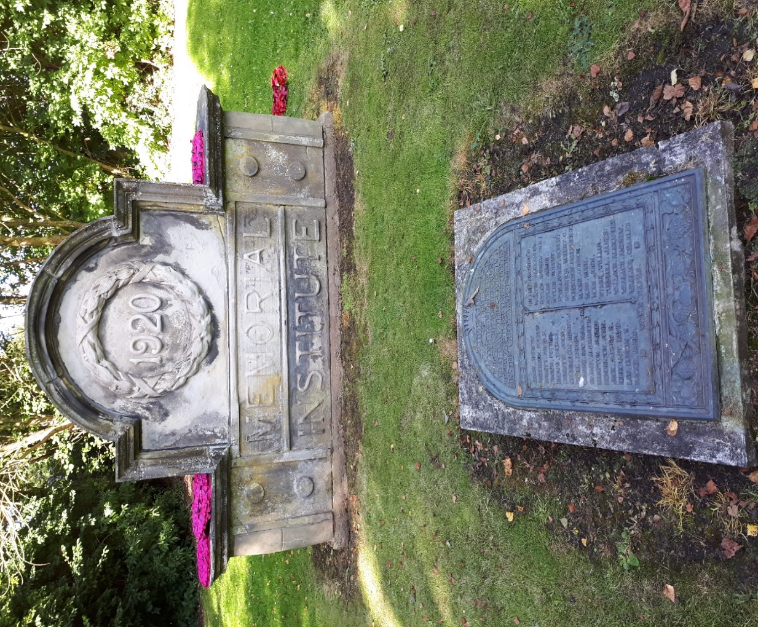The Guardbridge Community Development Trust would therefore, in an effort to help rekindle that sense of community spirit and bring a heart to the village that was lost when the paper mill closed, would like to see a new war memorial built. The present War Memorial is the name stone from the Memorial Institute built in 1922 which is now privately owned. The name plaque’s history is unknown although it may have been attached to the Memorial Institute. It is clear that the present memorial is a cobbled together effort and in our opinion is not fit for purpose. The University of St Andrews bought the old paper mill site in 2010 and are at present developing it into an energy park, now named the Eden Campus. A loss of identity for the village in itself as it was formerly known as the Guardbridge Paper Mill. However, this development has brought a sense of change for the better, one which the Guardbridge Community Development Trust are hoping to capitalise, and we see the building of a new war memorial as a catalyst in nurturing the growth of this renewed sense of identity and community spirit.

**The Proposed New War Memorial (West View)**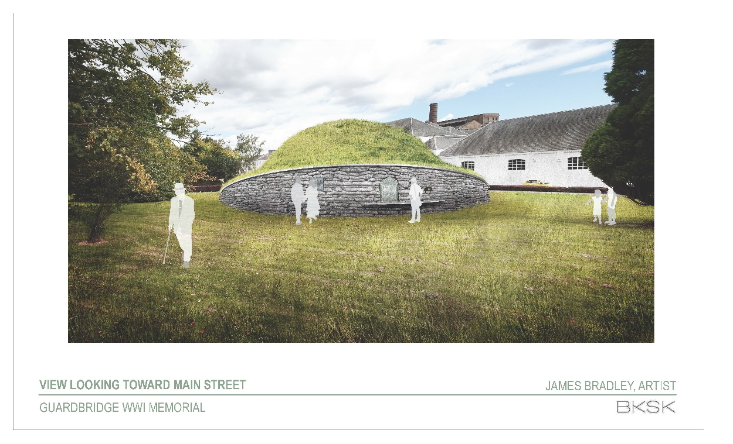

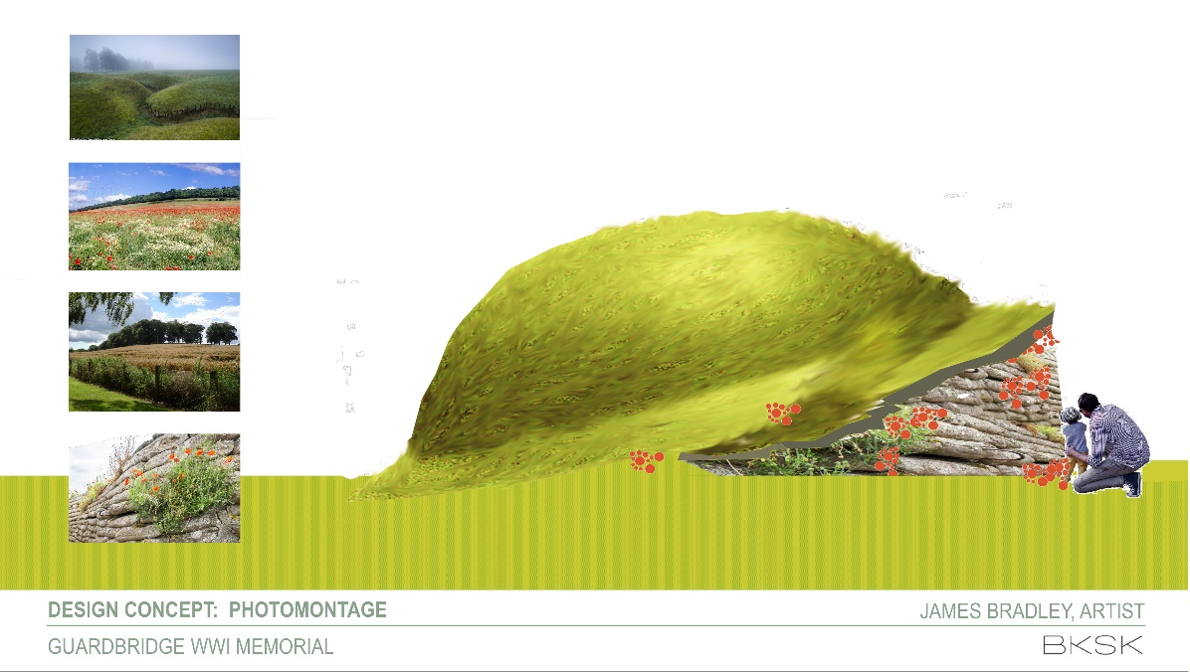**The Proposed New Memorial Side View**

**The Proposed New War Memorial (Site Plan)**

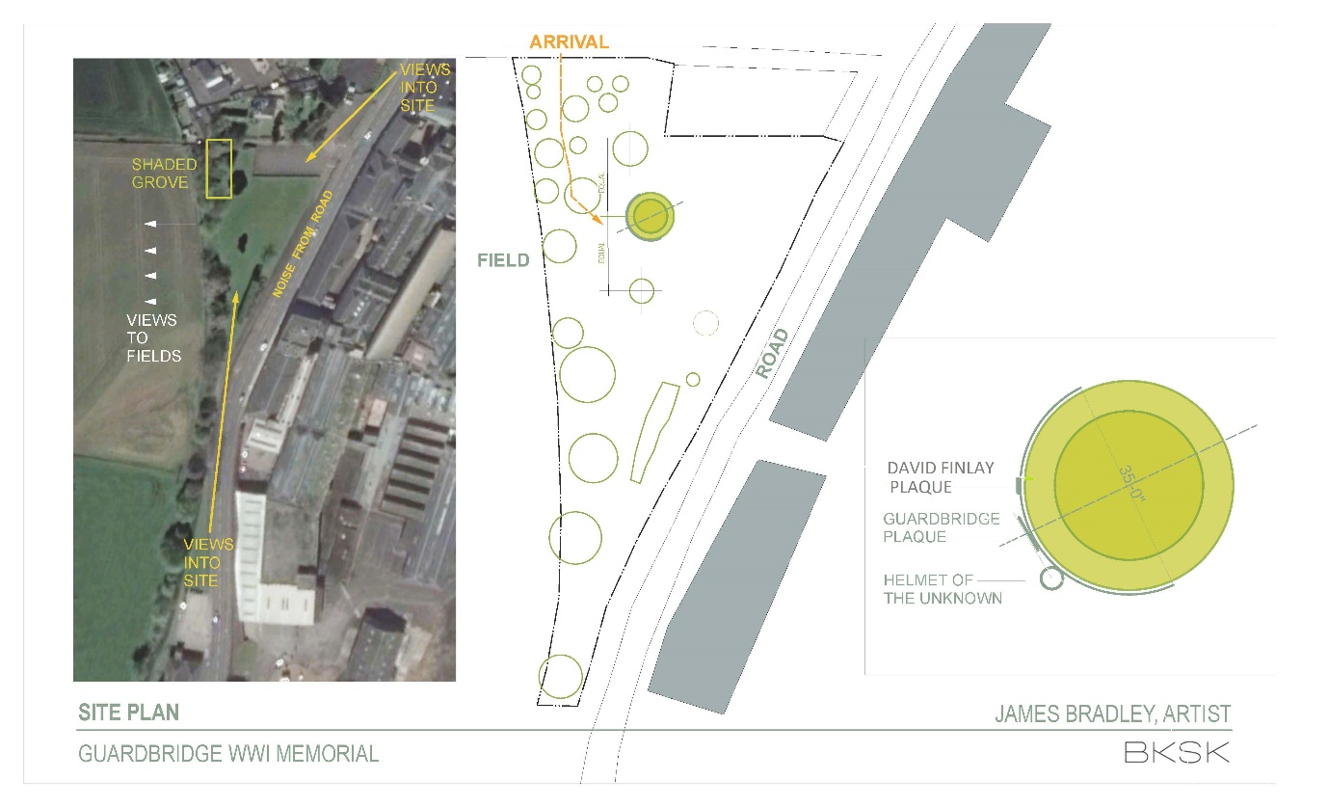

The basic idea of the above, is that of the shape of a WW1 helmet just above the wall of a trench with the name plaques on the ‘trench wall’. One novel idea is to have a QR codes against each of the names on the plaque which can then be read using a mobile phone app, thus making the whole memorial much more generationally interactive, especially for young people.

The Guardbridge Community Development Trust feel that the installation would also bring a focal point for the community remembrance of both wars, could involve the local school children (e.g. plant poppies in the ‘trench face’) and ‘lest we forget’ bring history alive. In essence it would preserve and enhance the village’s past in order to promote the future.

Yours Hopefully

Bill Wilson

Chair of Guardbridge Community Development Trust.