# Appendix 1

# Plan for Fife Local Outcome Improvement Plan 2017-2027

## This is your plan

The Fife Partnership is Fife’s community planning partnership. Our job is to bring together local public service providers and communities to improve the quality of life for people who live in, work in or visit Fife. Over the next ten years, we will put people and communities at the heart of everything we do as a partnership.

We will build on the good work that has already been done in order to bring about even greater improvements for Fife’s communities. This will need drive, enthusiasm and courage. As you’ll see as you read this plan, we don’t think that being average is good enough. Because of the inequalities that exist across Fife, an average performance means that some people and some places are losing out. So we want Fife to be exceptional, not just average.

Despite all the changes and uncertainty in the world at present, we aim to be forward looking and ambitious for Fife. So this plan focuses on creating opportunities for young people and families, as well as on creating thriving places where everyone has opportunities to play a full and active part in Fife’s social and economic life. We intend to create public services that are led by the needs and wishes of communities. A big part of what we plan to do is to involve local communities in designing places and services and, if they want to, in helping to deliver their own improvements. This could mean communities taking on responsibility for some local assets, such as community halls, libraries and open spaces. Wherever community groups want to play a bigger part in community planning and delivery, we’ll do our best to support them.

The Plan for Fife is Fife’s new community plan. It aims to deliver real improvements for the people of Fife. It doesn’t cover everything we aim to do over the next ten years, but it provides a clear focus for all our other plans. Sitting alongside this plan are the Local Development Plan (FIFEplan), which deals with physical and spatial planning issues, and the Climate Change Strategy, which sets out what we plan to do to address climate change and its likely impacts. We also have seven local community plans – one for each of our local committee areas. (See Figure 1.)

We don’t intend to create complicated processes to deliver this plan – wherever we can, we aim to simplify these.

We hope you support this Plan for Fife and that you feel you can get involved in creating a Fairer Fife over the coming weeks, months and years.

**Cllrs David Alexander and David Ross,  
Co-chairs, Fife Partnership**

Figure 1

Plan for Fife

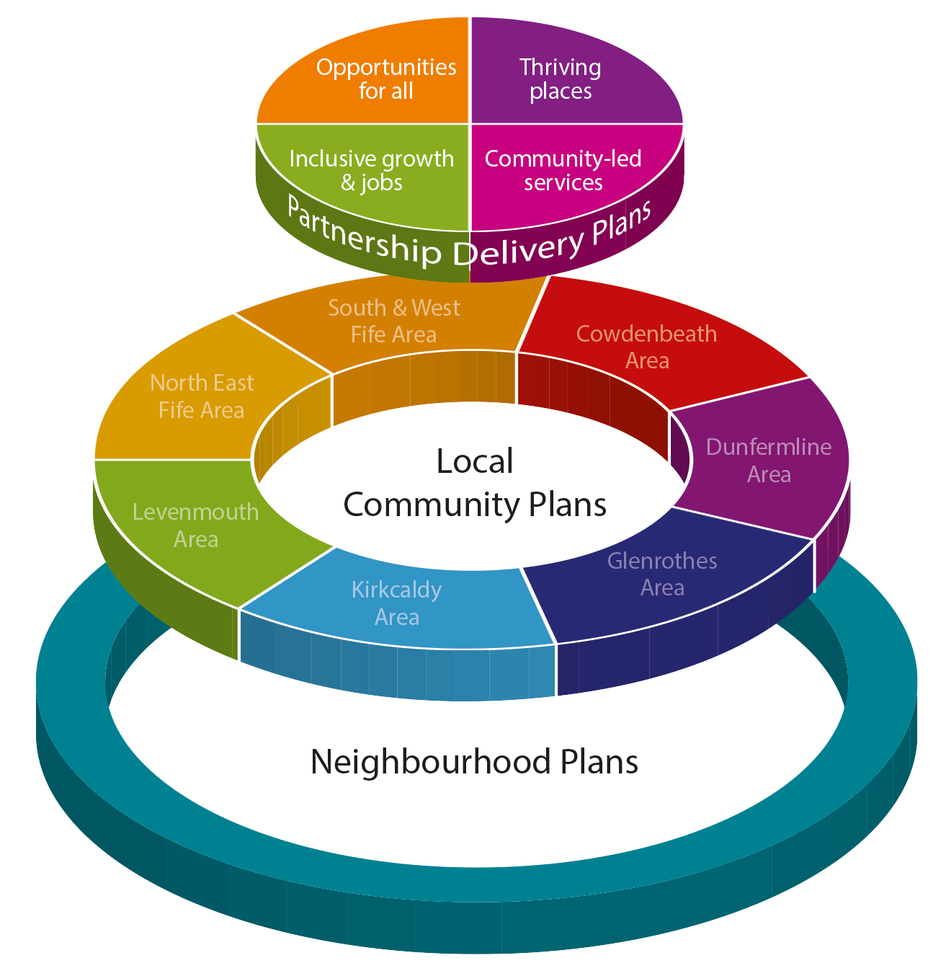

## What does this mean for you, and how can you get involved?

Many groups and organisations are already making a real difference in communities across Fife. We want to encourage others to get involved and make it easy for people to work with us to make a difference in Fife. We are encouraged by the positive responses we’ve received to our consultation on the draft plan and we’ll continue to work with people in local communities to involve them in decisions that affect them.

Here are some ways you can get involved:

* Visit [**Let’s Talk** **about Fife’s Future**](http://wordpress.fifedirect.org.uk/letstalk/get-involved/)to keep up to date with what is happening;
* If you would like to become more involved and give us your views on a range of topics, you can become a member of the [Fife People’s Panel](https://www.fifedirect.org.uk/topics/index.cfm?fuseaction=page.display&p2sid=2E1006A1-65BF-00F7-D23180B34404CC11&themeid=2B892409-722D-4F61-B1CC-7DE81CC06A90);
* Why not [pledge your support for a Fairer Fife](http://fairer.fife.scot/the-pledge/)?
* Volunteer in your local community or join a local group - you can get information via [Fife Voluntary Action](https://www.fifevoluntaryaction.org.uk/index.asp);
* Community groups can submit a [participation request](https://www.fifedirect.org.uk/topics/index.cfm?fuseaction=page.display&p2sid=04E5329D-9C91-6929-465F72E2F4325167&themeid=2B892409-722D-4F61-B1CC-7DE81CC06A90) to public organisations if they would like to take part in planning how services can be improved;
* If you are a local business, there are a number of [useful networks](http://www.fifedirect.org.uk/businessvoice) you can join.

There will also be opportunities to get involved in the work we do in local communities through [local community planning](http://wordpress.fifedirect.org.uk/letstalk/local/).

“I hope this can be achieved involving local residents”

“The priorities are right and attempt to make a difference to people's lives. The austerity measures from Westminster pressurising local councils to cut the community projects which provided vital services have led to tremendous hardship. I am very glad to see Fife Council looking for new and innovative ways to challenge this and address the shortfall.”

“The Plan for Fife is very good.  It covers a variety of subjects.  It will be good to get the community involved with decisions about their area.”

“I found the plan overly optimistic and likely to be unachievable without significant increase in funding”

“Encourage pride in community affairs and to take part in making things better”

“Would like to see a more focused action plan to deliver some of the details below the approach. At the moment, it is all very aspirational”

“The draft plan understandably reflects Fife Council’s current structures and their respective issues, however this does not necessarily correspond to the concerns of Fife residents.”

## How will we let you know how we’re doing?

We will produce an annual report in September each year. This will provide information on:

* How we’ve changed the way we work in partnership and with communities;
* What we have done to improve the outcomes set out in the Plan for Fife;
* How we have used our resources to deliver activities and outcomes;
* How we have been working with local communities to plan and deliver improvements;
* What we have achieved through our local community plans and neighbourhood plans.

If you would like to let us know what you think about the work we are doing in Fife, please use this form to do so. (Hyperlink to online form or page about how to get involved)

## Our Vision for Fife - A Fairer Fife

By 2027 we want Fife to be a place where all residents live good lives, make informed choices and have a sense of control so that they can reach their full potential, and where all children are safe, happy and healthy. We also want Fife to be a place where we make best use of our assets and facilities, while sustaining them for future generations.

In September 2014 the Fife Partnership set up the independent [Fairer Fife Commission](http://fairer.fife.scot/fairer-fife-commission/). The Commission’s remit was to:

‘Take a strategic overview of the scale, scope and nature of poverty in Fife and the effectiveness of activity currently undertaken to address such poverty, and to report with recommendations to Fife Council and Fife Partnership by November, 2015.’

The Commission considered a range of evidence, including hearing from people who have direct experience of poverty.

The [Fairness Matters report](http://wordpress.fifedirect.org.uk/fairerfife/wp-content/uploads/sites/24/2016/11/Fairness_Matters_Report_2015.pdf) was published in November 2015, and the Fife Partnership agreed to all its recommendations. The Partnership made a commitment to work together to deliver on these recommendations by 2030.

The Fife Partnership also agreed to fully refresh our existing community plan in line with the Community Empowerment (Scotland) Act 2015.

We’re responding to the Fairness Matters’ challenge to be ambitious for Fife by putting **a Fairer Fife** at the heart of our new plan. We aim to reduce inequalities and to promote fairness in everything we do. This will involve a big effort by all our partners, including the Third Sector and the business community. All our partners recognise that having a Fairer Fife will benefit everyone.

Within this overall vision, we have identified four priority themes to direct our work over the next ten years. These are:

### 1. Opportunities for All

*Opportunities for All* is about ensuring that no-one is left behind. We aim to ensure that every Fifer can access opportunities in education, training, jobs and wider society, and that all Fifers have equal access to the support and advice they might need to support a fulfilling and decent life.

### 2. Thriving Places

*Thriving Places* are safe, well designed and maintained places that promote wellbeing, where people are proud to be, and where they have access to the services and facilities they need at different stages of their lives.

### 3. Inclusive Growth and jobs

Growth in the local economy should benefit everyone, and shouldn’t pass people and places by. We will therefore focus on improving investment, growth and participation by businesses, people and communities, particularly in the mid-Fife area. We aim to support businesses to grow and to make sure that communities benefit from new business investment.

### 4. Community Led Services

Community Led Services means putting communities and service users at the heart of how we design services, and building on the strengths and assets we have in our workforce and in our communities in order to deliver valued services.

## What we know already and how we will use this information

Our Plan for Fife comes from a broad base of evidence that has been gathered using local and national information.

The [Fife Strategic Assessment](http://publications.fifedirect.org.uk/c64_StrategicAssessment2017final.pdf) provides an overview of Fife for organisations that are planning and providing services. It uses local and national research to help us understand different aspects of life in Fife. We have also carried out a number of local assessments to look at the issues affecting each of Fife’s seven local committee areas.

As well as this, we have examined local and national data on health and social care. [Fife’s Health and Social Care Partnership](http://www.fifehealthandsocialcare.org/) has developed local profiles to work with people to plan and measure services in Fife’s seven areas. These profiles include information on people’s health, home care provision, housing and carers, as well as information about community facilities, and people’s views about social care and health services.

### What does the evidence tell us?

* The **national and international context** is having a greater impact than usual on local issues in Fife. This includes the effects of the 2008 global financial crisis, UK recession, welfare reform and uncertainty around Brexit and Scottish independence.
* **Demographic changes** present major challenges, especially the growing number of people aged 75 and over, and the declining ratio of working age people who help support the wider population.
* Progress in achieving **community planning outcomes**, such as jobs, incomes and better health, tends to follow national averages rather than being exceptional. But the Fife ‘average’ disguises a number inequalities experienced by many residents.
* **Mid-Fife** presents a number of challenges. It has some of the poorest outcomes in Scotland in areas like jobs, health and deprivation. The area is generally doing less well than we would expect based upon the make-up of its population. This is partly due to poor connections with the rest of Fife and Scotland.
* **Population groups** that are aren’t doing as well as expected include people living in rural areas and people living in hard pressed circumstances.
* **Inequality** continues to increase and this is a major risk for Fife.
* **Making better use of assets** provides an important opportunity to improve outcomes. This includes areas like tourism and the use of public assets, like the countryside and historic buildings.
* **Welfare reform** will have a major impact on many people in Fife and on the local economy.
* Fife faces **economic challenges**. It has a much lower gross value added (GVA) than might be expected, very high unemployment in some areas and a challenging economic climate ahead.
* **Climate change** is the main environmental challenge, and risks from flooding are major concerns.

## Working locally to improve our communities

The Fife Partnership has already prepared a local community plan for each of Fife’s seven local committee areas. We will continue to support local community planning and continue to decentralise services and decision making to local areas.

We will review and update our local community plans on a regular basis – highlighting the key challenges and opportunities for communities across Fife. They will also identify the main priorities for local people, and will be used to plan partnership activity and to help allocate resources. The plans will reflect the four main priorities set out in the Plan for Fife.

At the same time, the Health and Social Care Partnership is developing seven local area plans. These will be used to help plan and coordinate the delivery of health and social care services across Fife. Along with other plans, like local policing plans, these will be a key part of our local community plan delivery arrangements.

The Plan for Fife focuses on how partners can work together more effectively to create a Fairer Fife. As well as focusing on the four priorities, we also aim to produce a number of targeted neighbourhood plans over the next three years. Work is underway to extend and develop Fife’s approach to neighbourhood planning. This will build on existing work, while meeting the requirements of the Community Empowerment Act. These plans will help us to target our efforts in those areas in Fife that are facing the biggest challenges. We’ll identify a number of smaller neighbourhoods across Fife that are currently experiencing the poorest outcomes in areas such as jobs, incomes, health and housing. We’ll then work with people in the local community to identify how best we can support them to address these issues and build successful and thriving places.

All community planning partners are committed to working together to make this happen. Much of this work is already happening in local neighbourhoods, but by developing neighbourhood plans, we aim to co-ordinate our collective efforts much more effectively. A number of areas already have community action plans in place, and these will continue to provide a focus for local improvement work.

## Shared leadership and our resources

By 2027 we aim to achieve a Fairer Fife through the development of services and approaches which:

* encourage people to take responsibility and make a difference
* build self-belief and confidence in people and communities
* promote organisational cultures that are facilitating and enabling
* integrate provision and work with communities to get the design right
* devolve decision making and strengthen accountability locally
* focus on prevention, anticipation and collaboration in our use of public resources

Partner organisations are committed to working together and with communities to make Fife a fairer place. We all have our individual plans and we will continue to deliver local services to the best of our ability given current financial challenges. At the same time, we aim to come together to improve the way we work to make a real difference for those parts of Fife, and those people, facing the biggest challenges.

The overall Fife Council revenue budget for 2017/18 is £771 million. The Council employs over 14,600 people. Other partners, notably NHS Fife, contribute further resources. NHS Fife has a budget of £766 million in 2017/18, of which £342 million is managed by the Health and Social Care Partnership. Fife College has a budget of over £47 million and over 1,100 members of staff. Other partners, like Police Scotland, Scottish Fire and Rescue Service and Fife’s Third Sector also bring considerable resources to the table.

Public and Third Sector organisations will have to make substantial financial savings over the next few years, and some of these will have an impact on the services we deliver. However, there are still substantial resources available to make a real difference for the people of Fife. Wherever possible, we’ll share our resources – including knowledge, people, buildings and vehicles – to deliver a ‘One Fife’ approach to public services.

Over the next few years, we’ll be looking to use our collective resources much more efficiently, and much more effectively, to support the delivery of our shared priorities. We’ll regularly review whether the way we use our resources is what’s needed in order to meet our ambitions. We’ll then make any changes that are needed.

## Delivering a Fairer Fife

Figure 2 provides a framework for the new Plan for Fife. This puts tackling inequalities at the centre of the plan, with a focus on making Fife fairer running through everything we do. The following sections go into more detail about each of the four priority areas, highlighting the main challenges and what we plan to do to meet these challenges. The Plan for Fife is the overall community plan for Fife, sitting alongside our Local Development Plan (FifePlan), which covers spatial and physical planning issues, and the Climate Change Strategy. The plan will be delivered through a number of outcome delivery plans. The main delivery plans are listed in Appendix 1. These plans provide further information about the actions set out in the following sections.

The Fife Partnership Board will oversee the delivery of the Plan for Fife. The Partnership Board includes many of Fife’s key community planning partners. Other key partners are represented on a number of partnership outcome boards, which will oversee delivery of key actions.

To make sure we’re making progress towards a Fairer Fife, we have identified 12 Ambitions for a Fairer Fife (Figure 3). We’ll use these 12 ambitions to measure how well we’re doing. We’ll set out our progress each year in an annual report, and we’ll review the Plan every three years to take account of any changes in the challenges and opportunities we have in Fife. Most importantly, we’ll continue our conversations with Fife’s communities to make sure that we’re making the changes that people want and need to enable them to live safe, healthy and happy lives.

Figure 2

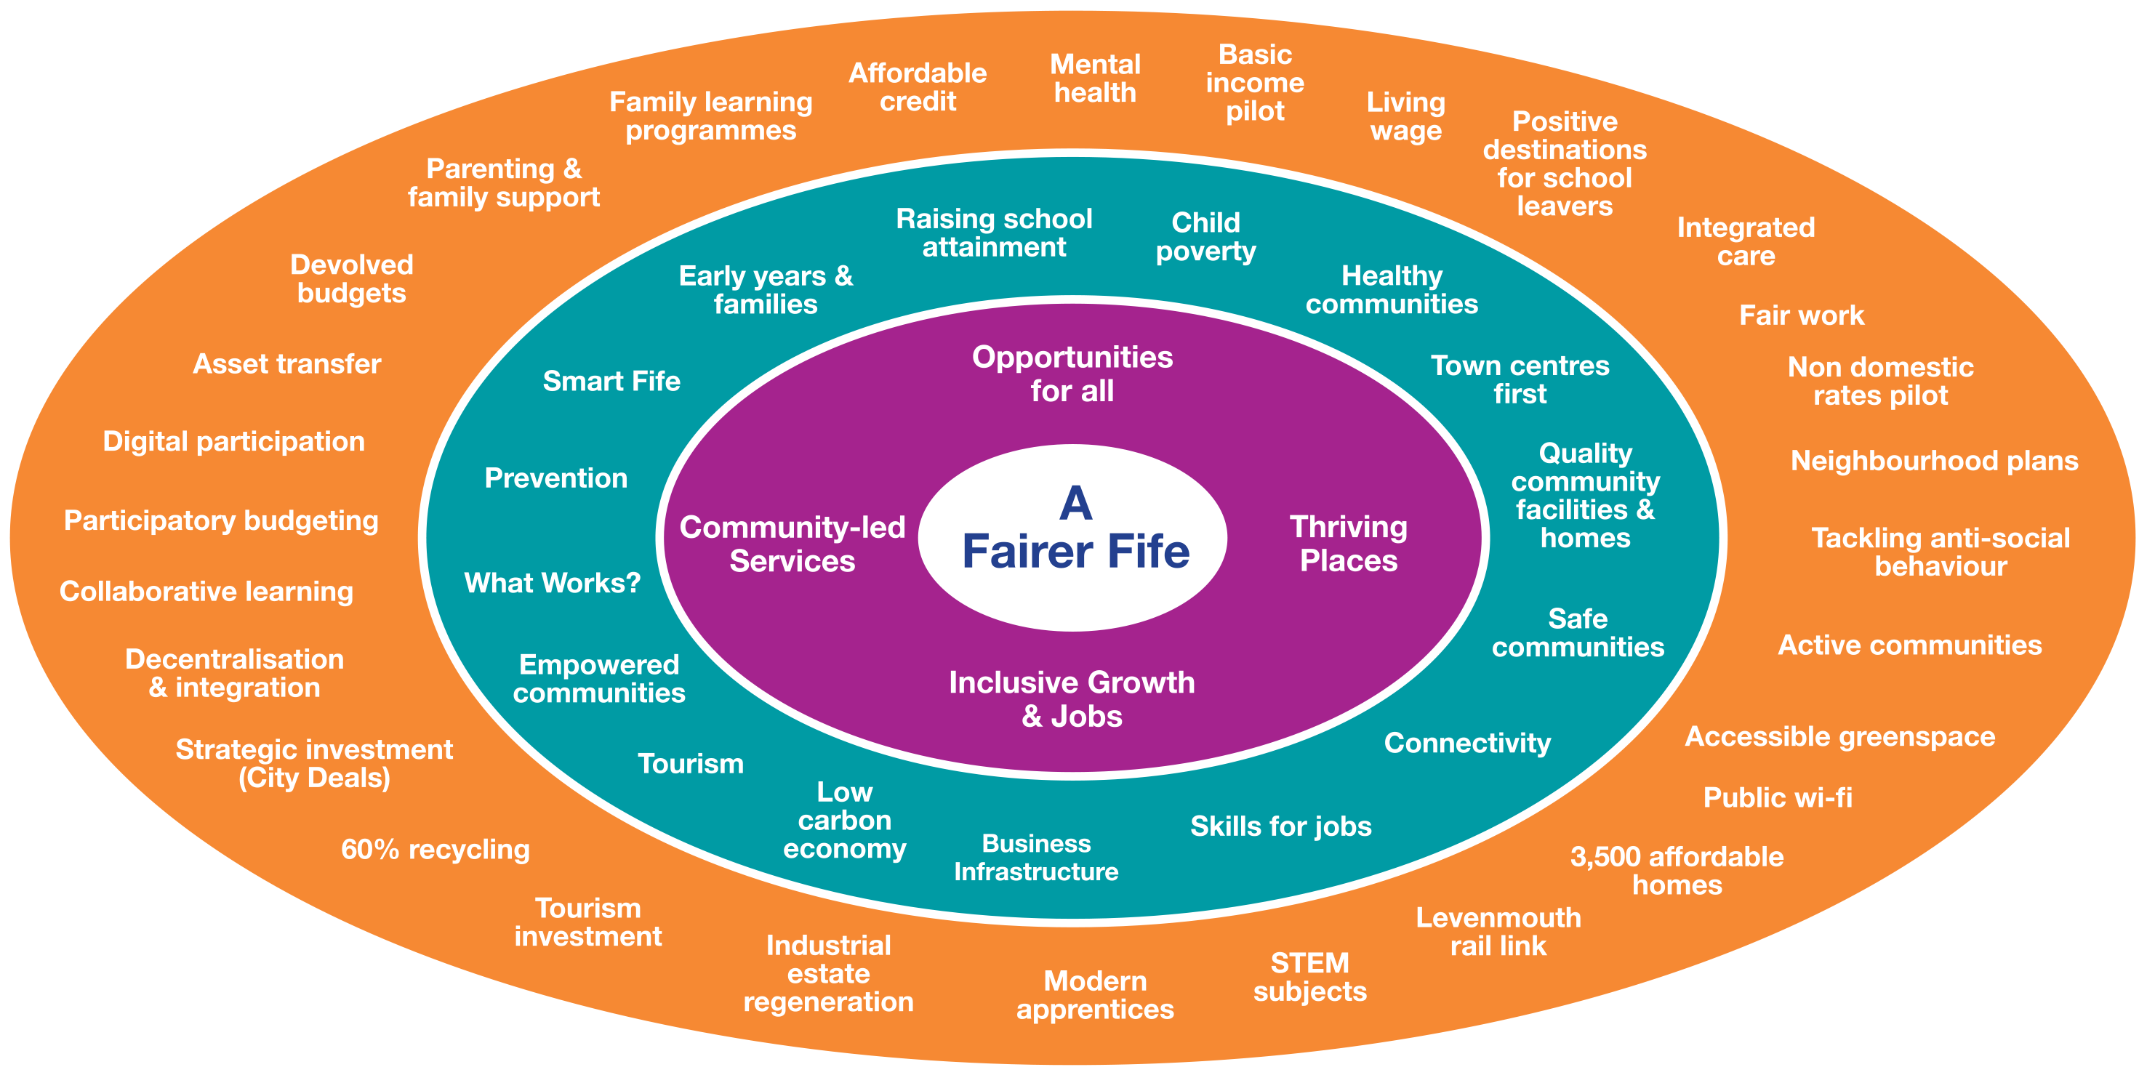

Figure 3

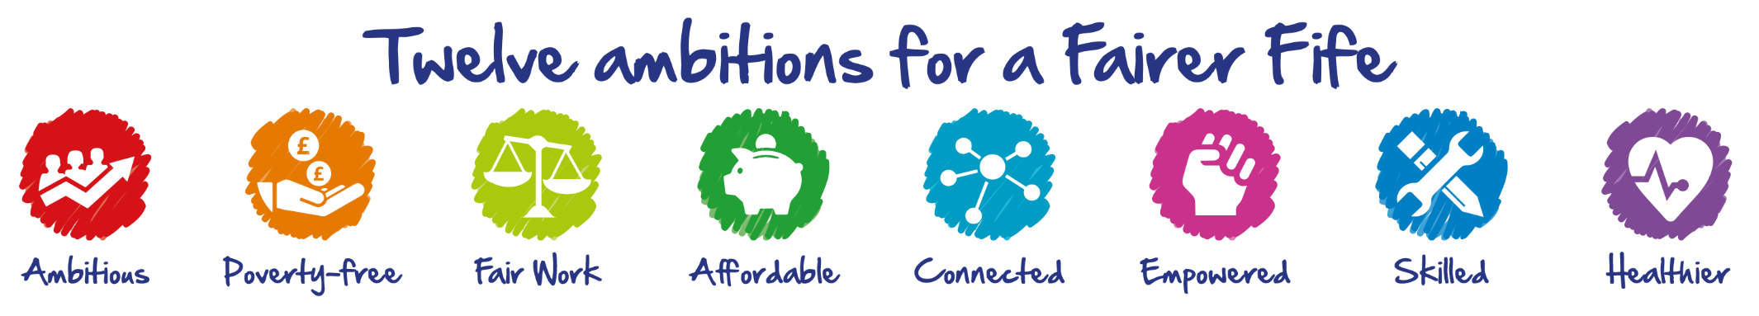

|  |  |  |
| --- | --- | --- |
| 1. By supporting people to maximise household incomes, act to reduce poverty levels in Fife. | 2. Increase employment through investing in infrastructure and growing jobs in the Green Economy, Tourism and Science Technology, Engineering and Maths. | 3. Make Fife one of Scotland’s best loved tourist destinations by attracting more visitors, year round, and increasing the annual visitor spend. |
| 4. Support early years development of children, with more meeting their key developmental milestones by 27-30 month review. | 5.Improve attainment of children at P1, P4, P7 for Literacy and Numeracy, and close the gap between most and least deprived areas. | 6.Better outcomes for school leavers with more going into positive destinations. |
| 7. Improve health and reduce the gap in premature mortality (under 75) from all causes. | 8. Improve affordability, for example by improving the availability, condition and mix of housing in Fife. | 9. Invest in better connected and digitally enabled communities and town centres and improve local environments. |
| 10. Keep communities safe and secure by investing in prevention and protection. | 11. Strengthen the role of communities in local community planning to enable local people to have greater influence over decisions that affect their local area. | 12. Improve how our organisations work together proactively and preventatively to provide innovative and responsive public services for the people of Fife. |

**Opportunities for All**

|  |
| --- |
| Opportunities for All is about ensuring that no-one is left behind. We aim to ensure that every Fifer can access opportunities in education, training, jobs and wider society, and that all Fifers have equal access to the support and advice they might need to support a fulfilling and decent life. |

**Our Ambition for Fife**

Many people in Fife have poorer access to opportunities than others. Mid-Fife has some of the poorest outcomes in terms of health, deprivation and jobs. Because of this, many people have less of a chance of realising their potential and of having good outcomes in areas like health and education. Living in poverty can severely limit people’s opportunities. Around one in five children in Fife live in a low income household. More than a third of Fifers live in fuel poverty. Around 24,000 people are unsure about how they can pay for the food they need. One in ten of the working age population are considered to be ‘employment deprived’, i.e., they don’t have access to the type and amount of employment they need to have a good quality of life. This situation is becoming worse. Welfare benefit changes are expected to lead to a loss of £153 million a year for households in Fife. This represents a significant loss to our local economy.

We intend to work closely together to eradicate deep and persistent poverty, to tackle the cost of living crisis, and to address issues that limit the aspirations of many Fife residents. We will particularly focus on promoting the life chances of young people. Only by doing this can we break the cycles of poverty and disadvantage that affect successive generations. Our children’s services, together with our further education, voluntary sector and health services, have a key role to play in achieving this. Elsewhere in this plan we set out a number of actions to promote inclusive growth and jobs. The aim is not just to improve the labour market and economic prosperity, but to ensure that those most in need see the benefits from our activities. Some of our poorest communities are defined by their life circumstances rather than where they live – for example, lone parents, disabled people, people with limiting health conditions and looked after children.

**Our Challenges**

* Many people in Fife are unable to manage financially and suffer from significant insecurity and lack of control as a result.
* People without work, including people with a disability and with mental health issues need to gain the skills and have access to the support they need to enter and sustain employment.
* People’s life chances and ability to participate are being affected by physical and mental wellbeing and health inequalities.
* Too many children in Fife live in poverty and have limited life chances.
* A need for services work better together to support the wellbeing of children, particularly the most vulnerable.
* Too few children are ready to learn when they start school
* There are significant differences in educational outcomes and life chances for children living in the most and least deprived areas.
* Children, young people and families are not involved enough in the decisions that affect their lives.

| **Where we want to be in 2027** | **The change we need to make** | **Actions for 2017-20** |
| --- | --- | --- |
| People are able to take up learning, work and voluntary opportunities, to save and to access affordable credit. | Develop a more coherent package of support measures, including income maximisation checks, concessions and benefits, and access to affordable finance. | * Monitor the impact of welfare changes and coordinate support locally to deliver mitigation measures. * Provide training for staff across the Fife Partnership to enable them to identify poverty and fuel poverty. * Promote banking options and strengthen credit union services, supported by the new social enterprise lending agency (CDFI). * Promote Fife as a Living Wage region and look at the role of procurement in supporting this. * Introduce income maximisation at key points in service provision. * Develop our approach to concessions and cost reduction to ensure cost is not a barrier to participation. * Explore a local pilot for implementing a basic income. |
| More children are ready to learn when they start school, particularly children living in poverty. | Ensure a greater focus on early intervention and prevention across children’s services to help build the resilience of families and improve access to support services, including childcare, early learning and health visiting. | * Improve advocacy and support to enable families and pregnant women to deal with benefit changes, maximise income and be more financially resilient. * Implement the Universal Health Visiting Pathway and support families with attachment at the earliest stages. * Improve access to local, affordable and flexible childcare, including exploring parent led approaches to support child development and to let families take advantage of learning, training and job opportunities. * Improve family engagement and support the need for early communication and language development through the roll-out of ELIPS assessment programme. |
| Educational attainment has improved for all learners and the attainment gap has reduced. | Improve staff understanding of the attainment gap and ensure they are confident and are supported in using interventions that close the gap. | * Work with partners across South East Scotland to implement the National Framework and delivery of the Pupil Equity Fund. * Support evidence-based approaches to closing the attainment gap. * Identify and address cost and other barriers to participation in school. |
| Our school leavers, including those from households living in poverty, achieve a positive destination. | Work with employers, schools, colleges and universities to maximise the opportunities open to young people in all parts of Fife. | * Led by the private sector, implement an action plan to develop the young workforce. * Involve employers in influencing and designing the curriculum for schools and colleges * Increase direct employer inputs with young people to improve awareness of careers opportunities * Target groups that are less likely to achieve by taking positive action, including addressing gender balance issues in terms of information and recruitment practices. |
| Fife has better health outcomes, combined with a reduction in the gap in outcomes across Fife. | We will promote greater investment in local and community networks and solutions. | * Strengthen the role of preventative health interventions to address cancer, coronary heart disease and alcohol related harm, particularly in the most disadvantaged communities. * Promote active and healthy lifestyles to help combat conditions such as obesity and diabetes. * Develop community capability and resilience by establishing locality groups and plans and supporting community projects. * Redesign care and support services to provide greater collaboration, more user choice and control, and to support people at particular risk of harm, deterioration or hospital admission. * Invest in digital solutions to promote self-monitoring, early intervention and prevention. |
| The wellbeing of children and young people is well supported, particularly the most vulnerable. | Develop a greater capacity across all children’s services to support the wellbeing of children and young people, and review our services to ensure that there is effective support for the most vulnerable where it is needed. | * Implement the ‘Our Minds Matter Framework’ to improve our support for the emotional wellbeing of all children and young people, and to reduce the number of children and young people who need intensive support with mental health issues. * Implement the Child Wellbeing Pathway, to improve our support for children and young people, including the most vulnerable and those with disabilities. * Improve awareness of the impact of adverse childhood experiences along with the response of services. * Improve family support and prevention to increase the proportion of children supported in a home/kinship setting and to reduce the proportion of looked after children placed outwith Fife. |

Thriving places are well designed and maintained, safe places that promote wellbeing, where people are proud to be and where they have access to the services and facilities they need at the different stages of their lives.

**Our Ambition for Fife**

We aim to develop thriving places across Fife – places where people can live long, happy and fulfilling lives; and places that people want to visit and invest in. Just now, there are big differences between many communities in Fife, with many parts of mid-Fife in particular doing less well than they should. We will work together and with local communities to reduce these inequalities and to create places where people can live safe, healthy and active lives. We’ll also give local people a much bigger role in helping to plan their local places to ensure they are vibrant, distinctive and in keeping with the character of their surroundings - making the most of Fife’s valuable local landscapes, heritage and biodiversity, and meeting challenges of climate and economic change.

We aim to ensure that Fife’s local communities have a good range of local services that are easy to access, meeting the needs of both local residents and visitors. Our thriving places will be places where people feel they belong to their community, enjoy their environment and have access to high quality open spaces; good, affordable housing; and community facilities.

Our seven area committees and local community planning groups will co-ordinate our work to create thriving places through seven local community plans.To ensure we focus our efforts on those areas in Fife that are facing the biggest challenges, we will also develop a number of ‘neighbourhood plans’ In this way, we aim to target our resources carefully, with a focus on mid-Fife**,** while considering how best to connect people to the opportunities that are available throughout Fife and beyond.

**Our Challenges**

* Our town centres need to meet changing needs in order to support viable mixed economies and communities.
* The quality of the local environment in many communities is poorer than in other parts of Fife.
* Fife’s population is changing rapidly, with around 20,000 new homes needed over the next 10 years.
* Too many homes in Fife are poor quality, and Fife has high levels of fuel poverty.
* Many of our community facilities and amenities are in poor condition and do not meet the needs of local people.

| **Where we want to be in 2027** | **The change we need to make** | **Actions for 2017-20** |
| --- | --- | --- |
| Fife has thriving and resilient town centres that work well for residents, visitors and businesses. | Prioritise investment in key town centres through a ‘Town Centre First’ principle. | * Explore the use of non-domestic rates relief to support and promote town centres. * Use town centre funds to attract external funding to improve the environment and built heritage in town centres. * Promote ‘digital towns’, including free public Wi-Fi, in key Fife’s key town centres and in community buildings. * With local business groups, explore the potential for creating new Business Improvement Districts. * Bring derelict land and buildings back into use. |
| Communities are leading change in local areas. | Build capacity in local communities and ensure that local people are fully involved in local community planning and land use planning. | * Support the development of local plans, neighbourhood plans and community led action plans. * Deploy the Place Standard across Fife to help ensure that the quality of life in neighbourhoods continues to improve. * Extend and further develop the use of participatory budgeting to involve local people in decision making on the allocation of mainstream partner resources and in designing services. * Promote the use of a range of engagement approaches, such as the Place Standard and charrettes, to promote effective community engagement, in line with the National Standards for Community Engagement. * Support innovative ways for people to get involved and take direct control of change in their communities. * Support further devolution of decision making, while providing local people with the information and support they need to influence the issues that affect them. * Community planning partners will review their current approaches to encouraging and supporting volunteering |
| Every part of Fife has a high quality local environment and is considered to be a great place to live. | Deliver targeted investment in Fife’s public places and green spaces and promote new, sustainable management models. | * Implement measures that provide a quick response to local environmental issues and promote community pride in local public spaces. * Implement alternative, low-impact management models for parks and greenspace across Fife. * Implement a programme of sustainable management for Fife’s woodlands. * Expand the coverage of Fife’s woodlands in order to improve biodiversity, reduce flood risks, provide carbon sinks, produce local biomass energy, diversify the local economy and decontaminate old industrial sites. |
| All Fife’s communities are safe and free from anti-social behavior. | Invest in prevention and protection to improve local environments and address anti-social behavior, threats, risk and harm in private, public and virtual spaces. | * Deliver co-ordinated action to reduce anti-social behaviour, with a clear focus on those areas with the greatest problems. * Improve information sharing and collaborative working to promote public protection and safer communities. * Reduce levels of unintentional injury through targeted interventions and enhanced home safety visits. * Reduce levels of reoffending by providing provide additional support for people with an offending history. * Promote public health and public safety through better collaboration, including staff co-location, in the delivery regulation and public protection services. |
| Everyone has opportunities to participate in social, health, leisure, cultural, learning and employment activities. | Invest in high quality community facilities and amenities and sustainable travel options in local communities. | * Map community provision across Fife, identify gaps and take action to improve access to local assets and facilities. * Implement measures to improve access to green recreation and play space, especially in more deprived communities, in order to maximise health, education and biodiversity benefits, and support initiatives that reduce social isolation. * Develop a high quality active travel network and infrastructure to connect communities. * Develop the Fife Coastal Path and the Pilgrim’s Way as key recreational and tourism assets. * Improve affordable and sustainable travel and public transport, particularly in rural parts of Fife and during evenings and weekends. * Promote opportunities for people to take advantage of new technologies and the internet, including access to high speed broadband services and Wifi across Fife. * Promote participation in sport, physical activity and healthy lifestyles. |
| People in Fife have good quality and affordable housing. | Facilitate house building through well planned, sustainable communities, with adequate community infrastructure and affordable housing. | * Promote investment and align public sector capital investment to unlock developer funding for transport and education infrastructure. * Deliver an integrated approach to support the delivery of strategic housing across Fife’s nine identified ‘strategic development areas’. * Deliver a ‘Phase 3’ affordable housing programme of 3,500 homes by 2022. |
|  | Provide people with suitable and affordable housing choices, and increase investment in preventative services. | * Implement robust measures to improve private sector housing conditions. * Prevent homelessness by providing more housing options and supporting households to sustain their accommodation. * Deliver energy efficiency measures to reduce fuel poverty and improve health and wellbeing across all housing tenures. |

|  |
| --- |
| Growth in the local economy should benefit everyone, and shouldn’t pass people and places by. We will therefore focus on improving investment, growth and participation by businesses, people and communities, particularly in the mid-Fife area. We aim to support businesses to grow and to make sure that communities benefit from new business investment. |

**Our Ambition for Fife**

We know that Fife faces a number of economic challenges, including relatively low productivity, localised high unemployment and a challenging economic climate ahead. The mid-Fife area in particular has one of the highest levels of unemployment in Scotland, despite having two of Fife’s main centres of employment - Glenrothes and Kirkcaldy. This is partly because of a failure to connect people, businesses and places, not just within Fife, but nationally and globally.

We aim to reverse this and to connect our people, businesses and places within Fife, and with the rest of Scotland and the world. We also aim to promote sustainable, locally-rooted businesses that have a strong attachment to their local area, creating local jobs, promoting local supply chains and keeping more wealth and community benefits locally. We intend to promote investment to create more and better paid jobs. We also want more people participating economically and we want people to reach their full potential.

**Our Challenges**

* Lack of investment in Fife’s industrial estates and business infrastructure.
* Fife, and particularly mid-Fife, needs more businesses, with more of these trading outside Fife and investing in innovation and growth to
* Improve their resilience and competitiveness.
* Digital technology is rapidly changing and people and businesses need to keep up to date with this so they are not left behind.
* We are not making the most of all our tourism assets to grow existing or new businesses.
* Travelling around Fife to access work can be difficult and the cost of travel can also be a barrier.
* The need to reduce the local and global environmental impact of our consumption and production presents both a challenge and an opportunity for new economic activity

| **Where we want to be in 2027** | **The change we need to make** | **Actions for 2017-20** |
| --- | --- | --- |
| Fife has modern businesses, competing effectively at a regional, national and international level. | Invest in a modern business infrastructure and in developing national and international markets for Fife’s businesses. | * Secure investment in modern business clusters as a focus for business growth. * Regenerate our industrial estates, driven by innovation in digital and low carbon technologies. * Develop markets for Fife businesses, for example, for selling into public services and low carbon and digital businesses. * With national agencies deliver an international trade programme, both physical and digital, at a Fife and regional level. |
| Mid-Fife has benefited from new economic activity and assets arising from the reduced local and global environmental impact of our consumption and production. | Promote investment in sustainable businesses, waste reduction and energy generation, with a focus on mid-Fife. | * Deliver a business audit and action programme through Business Gateway Fife and Zero Waste Scotland. * Deliver a sustainable energy and climate action plan for Fife, and identify opportunities for sustainable businesses and energy generation. * Develop a mid-Fife green industry hub, including decommissioning. * Deliver a Zero Waste business development programme. |
| Fife is a leading local authority area for jobs in high skilled science, technology, engineering and maths (STEM) occupations. | Increase investment in training and business development to promote employment in science, technology, engineering and maths related businesses. | * Create more opportunities to upskill the existing workforce, and support continuing professional development (CPD) opportunities, along with further CPD for educators and leading attainment in STEM subjects * Develop a mid-Fife technology led business cluster, building on the network of business hubs, university spin-outs and commercialisation projects. * Use new technology to extend access to learning in STEM subjects. |
| Fife is a leading local authority area for the proportion of residents aged 16-64 in employment and/ or self-employed. | Promote increased investment in apprenticeships, skills development and business innovation. | * Roll out and extend foundation level, modern and graduate apprenticeship programmes. * Build connections between communities, colleges, universities and businesses to improve innovation. * Promote the Fife talent pool to attract new large employers with highly paid jobs. * Establish a pre-recruitment training programme. * Deliver a network of enterprise and incubation centres throughout Fife. |
| Fife is making the most of its unique natural, cultural and historic assets, and is a nationally and internationally recognised tourism destination. | Promote investment in a year round ‘whole Fife’ visitor economy, supporting high quality employment | * Develop a year-round tourism activity and events programme across Fife. * Develop area tourism asset registers and plans to accelerate the growth of tourism in key communities in mid-Fife. * Develop a Fife Winter Festival programme. * Maximise the potential of key tourism sectors, such as outdoor recreation and food and drink, along with key destinations, such as the Pilgrim’s Way, Fife Coastal Path and Forth Bridges. * Roll out a virtual technology interpretation programme. |
| There is effective movement of people, goods and services due to better connections, including digital connections, across Fife, and particularly mid-Fife. | Promote investment in transport infrastructure, digital connections and workforce mobility solutions. | * Develop business cases for investment in transport infrastructure, including the Levenmouth Rail Link, the A92 and Standing Stane Road. * Develop an investment plan for Fife’s digital assets. * Deliver a digital support programme to help more businesses adopt digital technologies faster. * Develop easy to use digital platforms to access sustainable travel information. * Explore ways of delivering a workforce mobility solution in mid-Fife, for example, a single travel card. * Roll out the workforce mobility solution to the rest of Fife and the city regions. |
| Physical and mental health issues are no barrier to achieving positive employment outcomes | Work with communities and businesses to ensure that physical and mental health issues are no longer a barrier to entering and sustaining work. | * Develop the business charter, which includes providing mental health friendly workplaces. * Redesign employability pathway activities to address physical and mental health challenges. |

|  |
| --- |
| Community Led Services means putting communities and service users at the heart of how we design services and building on the strengths and assets we possess in our workforce and our communities in order to deliver valued services. |

**Our Ambition for Fife**

Our public services face unprecedented challenges due to rising service demand, continuing resource constraints, and growing levels of need as a result of changes in areas such as welfare. This all means that current approaches to the design and delivery of services will become increasingly unsustainable. There is also a significant body of evidence to suggest that current organisational models and approaches to delivery in the public sector can work against an ambition of fairness. This was reinforced by the work of the Fairer Fife Commission. The Commission found that, in Fife, there is a good understanding of the role that citizens, service users and communities can play, alongside Fife’s investment of localised budgets and services. But the Commission found less evidence of real asset based work with communities to improve their resilience and develop opportunity. In responding to these challenges, we need to redesign services giving people and communities greater control, confidence and access to resources while ensuring greater collaboration and responsiveness at a local level.

We know that services work best when they are designed with the involvement of those who use them and depend on them. We also know that prevention and problem solving work most effectively where responsibility is devolved and people are supported to make a difference. The public sector can’t do everything, and future success lies in helping people do more for themselves, improving collaboration across different sectors and using the opportunities provided by technology to reduce costs and improve responsiveness and levels of empowerment.

**Our Challenges**

* There will be an increase in levels of need and service demand over the plan period.
* There will be a reduction in available funding.
* Many communities feel excluded from key decisions that affect their everyday lives.
* A great deal of public spending currently goes on dealing with the consequences of problems, rather than their causes.

| **Where we want to be in 2027** | **The change we need to make** | **Actions for 2017-20** |
| --- | --- | --- |
| We are achieving better outcomes for people and communities by shifting our focus from dealing with the consequences of problems towards prevention. | Enhance our use of data, and develop tools that help all partners to understand and measure levels of demand so that we can reduce ‘failure demand’, i.e. dealing with problems after they have already happened. | * Roll out demand management review tools across services areas. * Develop metrics that allow us to measure progress. * Enhance the role of data hubs and invest in research. * Review the role of partnership groups and strengthen the focus on prevention and innovation. |
| We have public services that inspire confidence and are highly valued by communities and service users. | Greater responsiveness, innovation and joint problem solving in partner organisations by encouraging more facilitating and enabling cultures. | * Create a focus on culture change in the partnership and across partner organisations. * Promote more collaborative working and learning. * Promote and encourage information sharing among local front-line staff. * Invest in decentralised delivery, service integration, workforce development and collaboration. |
| We have locally responsive services that are easy to access and influence. | Promote greater devolution of responsibility and accountability in order to support effective decentralisation, collaboration and service integration. | * Extend the use of participatory budgeting. * Review barriers and identify opportunities for devolved decision making across services. * Make local community planning and neighbourhoods central to community planning delivery arrangements. * Identify and further devolve budget to the local level |
| Fife is making good use of technology in order to design services and connect communities | Invest in digital infrastructure and applications, involving users and communities in designing services. | * Develop community digital opportunities to improve networking and knowledge sharing * Use social media and online tools as part of a wider programme to improve community provision. * Jointly invest in digital opportunities to improve access, information and knowledge and build community capacity. |
| We have well established models of community involvement and support. | Provide community groups with support and resources to enable them develop and sustain new models. | * Support community asset transfer. * Introduce integrated and community based design requirements for future changes to services by partners. * Strengthen the capacity of community groups to get involved. |

.

**Associated Plans and Strategies**

* FIFEplan (Local Development Plan)   
  <http://lpconsult.fife.gov.uk/portal/fife_ldp/fifeplan_-_adopted_plan_13/adopted_fifeplan>
* Climate Change Strategy 2014-2020   
  <http://publications.fifedirect.org.uk/c64_FEP-Climate-ChangeStrategy-2014.pdf>

**Current Partnership Delivery Plans**

* Fairer Fife Action Plan   
  <http://fairer.fife.scot/making-fife-fairer/our-progress/>
* Fife Economic Strategy 2017-2027   
  <http://fish.fife/fish/uploadfiles/Publications/EE222A5A-0187-8237-7E0E8C725B5863CA.pdf>
* Fife Tourism Strategy 2014-2024   
  <https://www.fifetourismpartnership.org/site/assets/files/2517/tourist_strategy_final_for_screen.pdf>
* Fife Children’s Services Plan 2017-20   
  <http://girfec.fife.scot/partnership-working/childrens-services/>
* Fife Health and Social Care Strategic Plan 2016-19 <http://publications.fifedirect.org.uk/c64_HSCP_Approved_Strategic_Plan_2016_incl_Appendices.pdf>
* Fairer Health for Fife: Fife’s Health Inequalities Strategy 2015-20  
  <http://wordpress.fifedirect.org.uk/healthyfife/wp-content/uploads/sites/53/2017/03/Fairer_Health_for_Fife_2015-2020.pdf>
* Fife Community Safety Partnership Strategy 2015-20  
  <http://publications.fifedirect.org.uk/c64_FCSP2015-2020FinalVersion171115v2.pdf>
* Fife Community Justice Outcome Improvement Plan
* Local Housing Strategy 2015-2020  
  <http://publications.fifedirect.org.uk/c64_160404MasterLHSandOutcomes1.pdf>
* Fuel Poverty Strategy
* SEStran Regional Transport Strategy 2015-2025  
  <http://www.sestran.gov.uk/wp-content/uploads/2016/11/SEStran_Regional_Transport_Strategy_Refresh_2015_Executive_Summary.pdf>
* Local Transport Strategy for Fife 2016-2019  
  <http://publications.fifedirect.org.uk/c64_LocalTransportStrategy.pdf>
* Sustainable Land Use Strategy
* Woodland and Forestry Strategy   
  <http://publications.fifedirect.org.uk/c64_FifeForestryWoodlandStrategy2013.pdf>
* Sustainable Energy Climate Action Plan
* Local Biodiversity Action Plan  
  <http://publications.fifedirect.org.uk/c64_FBLAP-final.pdf>
* Community Learning and Development Plan 2015-18   
  <http://fish.fife/subjects/index.cfm?fuseaction=page.display&pageid=B414D414-FE71-E0A9-F7971CF6D87366FD&subjectid=0F6E36B1-1CC4-E06A-520831283D05F5C6>
* Fife Sports Strategy 2014-18   
  <http://www.fish.fife/fish/minisites/index.cfm?fuseaction=page.display&pageid=EBCAE05C-BE74-70B1-128AEB56ED35A9EB&siteid=F45316A8-7236-4F0E-A8B788029725EBB6>